Below are two diagrams for you to construct.
Measure the lengths - there seem to be some that are equal!
But can you prove it?

Firstly:
Draw a square, and create an equilateral triangle on two adjacent sides of the square.
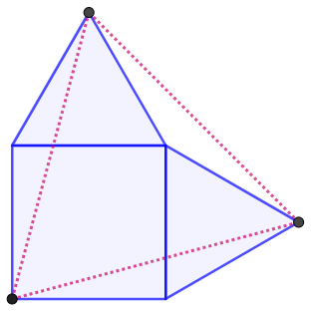
It looks like the two outside corners of the triangles, along with the opposite corner of the square, form another equilateral triangle... Can you prove it?
What if you constructed the equilateral triangles on adjacent sides of a rectangle, rather than a square?
What if the equilateral triangles are drawn inside the square? Inside the rectangle?
Secondly:
Draw a line and choose any point on the line. Construct two equilateral triangles on the line, one on either side of your chosen point. Join the apex of each triangle to the other end of the line.

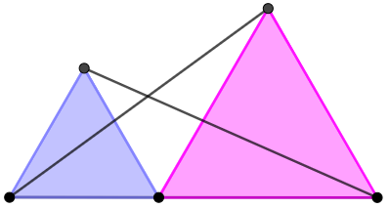

Draw some equilateral triangles of your own. Are the two lines always the same length?
Can you prove it?

